Practicum No.1 Date:……….

Develop solutions that perform arithmetic operations based on Input Size and Complexity Analysis

- Practical Significance

Modern digital systems operate with fixed data widths. Choosing an inappropriate bit-width may lead to overflow, incorrect results, or inefficient resource utilization. This experiment enables students to understand how selecting an appropriate data width (8-bit or 16-bit) based on input size prevents overflow while maintaining computational efficiency. Such decisions are fundamental in processor design, embedded systems, and low-level software development.

- Competency and Industry-Specific Practical Skills

Use the principles of computer architecture to optimize system performance
- Select appropriate MATLAB functions for numeric computation. (PDO)
- Implement robust code that handles input validation, exceptions and vectorized operations. (PDO)
- Interpret program outputs and validate correctness with test cases. (CDO)

- Relevant CO(s) (As stated in the Course Structure)

- CO1. Use the relevant instruction cycle to efficiently manage the processor's functionality.

- Practical Outcome (PrO) (As stated in the Course Structure)

- Develop solutions that perform arithmetic for the given data.

- Related ADO(s) (As stated in the Course Structure)

- Follow ethical practices in designing or evaluating the system design.
- Apply systematic design principles and debugging techniques.
- Function effectively as a team member.

- Minimum Underpinning Theory (Include relevant content & images for this practicum.)

Digital systems store and process data using fixed-width registers. An 8-bit data representation can store values from 0 to 255, while a 16-bit representation can store much larger values. When arithmetic results exceed the representable range, overflow occurs. Increasing data width is a common engineering solution to avoid overflow without altering the algorithm. Although the algorithmic complexity remains constant, memory usage increases with higher bit-width.

- Practicum Set-up/Circuit Diagram/Algorithm/Flowchart (Include probable photos of experimental set-up.)

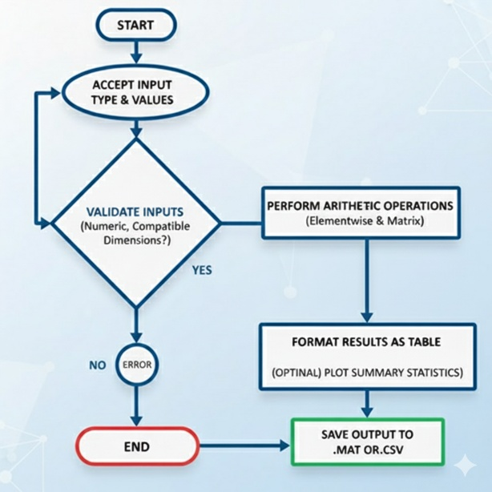

Algorithm
- Read two integer values from the user.
- Allow the user to select data width (8-bit or 16-bit).
- Perform addition using the selected data width.
- Check for overflow conditions.
- Display arithmetic result and memory usage.

- Resources Required

S. No. | Resource | Suggested Broad Specification | Quantity
1 | MATLAB | (R2016b or newer) or GNU Octave (with mostly compatible syntax). | 1 No.
2 | PC | PC with MATLAB installed. | 1 No.
3 | Sample datasets | (provided below) | 1 No.
4 | Text editor / MATLAB Editor | - | 1 No.

- Safety Precautions
- Save work frequently.
- Comment code and include header describing author, date, input format and usage.
- For shared code, remove hard-coded absolute paths.
- Validate user inputs to avoid runtime errors (division by zero, dimension mismatch).

- Procedure (Self-Instructional)
- Accept input type and values.
- Validate inputs (numeric, compatible dimensions).
- Perform requested arithmetic operations (elementwise and matrix where applicable).
- Format results as a table and (optionally) plot summary statistics.
- Save output to. mat or .csv.

% Selection of 8-bit / 16-bit Data Width Based on Input Size and Complexity Analysis
clc; clear;
a = input('Enter first integer value: ');
b = input('Enter second integer value: ');
choice = input('Enter bit width (8 or 16): ');
if choice == 8
a_val = uint8(a);
b_val = uint8(b);
sum_val = a_val + b_val;
fprintf('8-bit Result: %d\n', sum_val);
if (double(a) + double(b)) > 255
disp('Overflow occurred in 8-bit arithmetic');
disp('Design Hint: Increase data width to 16-bit to avoid overflow');
else
disp('No overflow in 8-bit arithmetic');
end
info = whos('a_val','b_val','sum_val');
totalBytes = sum([info.bytes]);
fprintf('Data type used : 8-bit\n');
fprintf('Memory per value : 1 byte\n');
fprintf('Total memory used: %d bytes\n', totalBytes);
elseif choice == 16
a_val = uint16(a);
b_val = uint16(b);
sum_val = a_val + b_val;

fprintf('16-bit Result: %d\n', sum_val);
disp('No overflow in 16-bit arithmetic');

info = whos('a_val','b_val','sum_val');
totalBytes = sum([info.bytes]);

fprintf('Data type used : 16-bit\n');
fprintf('Memory per value : 2 bytes\n');
fprintf('Total memory used: %d bytes\n', totalBytes);
else
disp('Invalid bit-width selection');
end
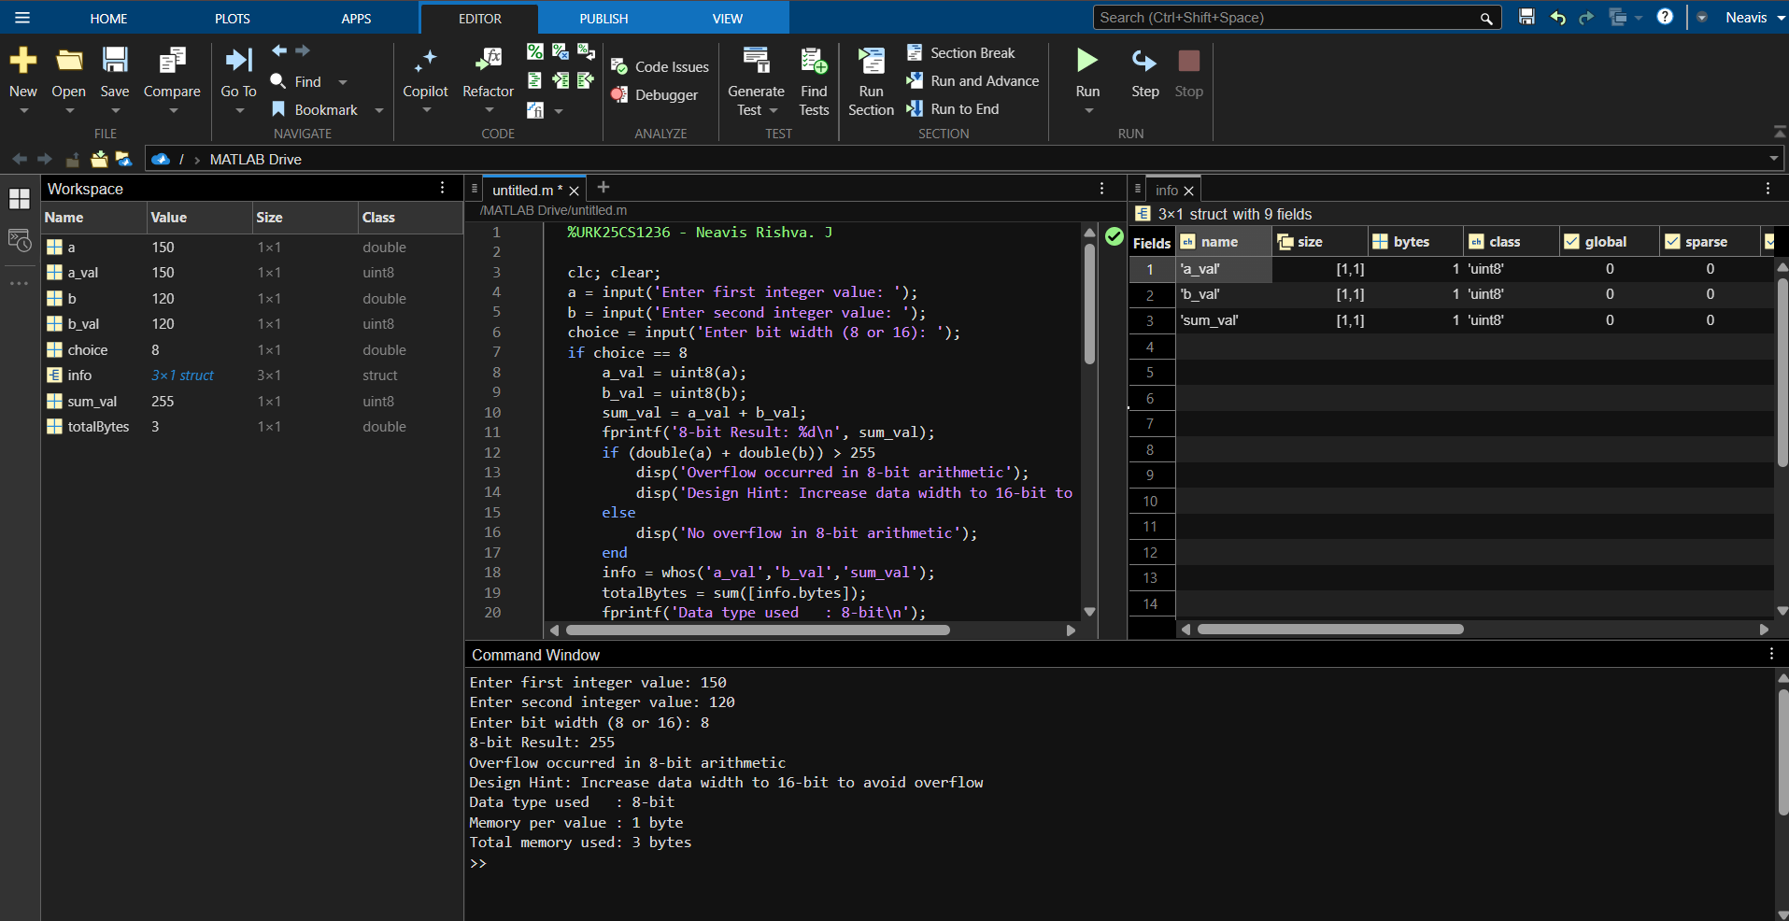

Sample Input & Sample Output (run Mode 2 — sample data)
Input:
Enter first integer value: 150
Enter second integer value: 120
Enter bit width (8 or 16): 8
Output:
8-bit Result: 14
Overflow occurred in 8-bit arithmetic
Design Hint: Increase data width to 16-bit to avoid overflow
Data type used: 8-bit
Memory per value: 1 byte
Total memory used: 3 bytes

- Actual Resources Used

S. No. | Name of Resource | Broad Specifications |  | Quantity | Remarks  (If any)
 |  | Make | Details
 | PC / Laptop | Asus | Intel Core i5 Processor, 8 GB RAM | 1 | Used for program execution
 | MATLAB Software | MathWorks | MATLAB R2019a (64-bit) | 1 | Arithmetic computation
 | Operating System | Microsoft | Windows 11 (64-bit) | 1 | Platform support
 | MATLAB Editor | MathWorks | Built-in Script Editor | 1 | Code development

- Actual Procedure Followed
- MATLAB software was opened and a new script file was created.
- Two integer values were taken as input from the user.
- The required data width (8-bit or 16-bit) was selected by the user.
- Addition operation was performed using the selected data width.
- Overflow condition and memory usage were observed and recorded.
- Observations and Dimensional Measurement (To be filled by the students)

S.  No. | Input Case ID | Input Value A | Input Value B | Data Width | Arithmetic Operation | Arithmetic Result | Overflow Status | Memory Used (Bytes) | Remarks
1 | TC01 | 100 | 50 | 8-bit | Addition | 150 | No Overflow | 3 | 8-bit range
2 | TC02 | 200 | 100 | 8-bit | Addition | 44 | Overflow | 3 | 300 > 255
3 | TC03 | 10 | 20 | 8-bit | Subtraction | 246 | Underflow | 3 | Negative value
4 | TC04 | 500 | 200 | 16-bit | Multiplication | 34464 | Overflow | 6 | 100000 > 65535

Note: Instructions for Filling the Table:
- Input Case ID:
  - Assign a unique identifier for each test case (Case–1, Case–2, etc.).
- Input Value A / B:
  - Enter the integer values provided to the program.
- Selected Data Width:
  - Specify whether 8-bit or 16-bit arithmetic was used.
- Arithmetic Result:
  - Record the output obtained after performing the arithmetic operation.
- Overflow Status:
  - Indicate whether overflow occurred (Yes / No) based on the selected data width.
- Memory Used (Bytes):
  - Record total memory usage as displayed by the program.
- Remarks:
  - Note observations such as overflow behavior, truncation, or suitability of the selected data width.
- Results/Observations

- The program successfully performed addition using both 8-bit and 16-bit unsigned integer data types.
- When 8-bit data width was selected and the sum exceeded 255, overflow occurred and the result was wrapped around.
- Overflow detection logic correctly identified when the result exceeded the maximum limit of 8-bit representation.
- No overflow was observed when 16-bit data width was used for the same input values.
- Memory usage increased when switching from 8-bit to 16-bit data width.
- For 8-bit arithmetic, each variable occupied 1 byte of memory.
- For 16-bit arithmetic, each variable occupied 2 bytes of memory.

- Interpretation of Results

- The results indicate that data width plays a crucial role in determining the correctness of arithmetic operations.
- 8-bit arithmetic is suitable only for small input values within the range of 0 to 255.
- When larger values are used, 8-bit arithmetic causes overflow, leading to incorrect results.
- 16-bit arithmetic provides a wider range of representation and eliminates overflow for larger inputs.
- Although 16-bit arithmetic uses more memory, it improves computational accuracy.

- Conclusions
- The experiment confirms that incorrect data width selection can result in overflow and inaccurate arithmetic results.
- 8-bit data width is memory efficient but limited in range and should be used only for small values.
- 16-bit data width is more reliable for larger numerical computations.
- Increasing data width is an effective solution to overflow without modifying the algorithm.
- Engineers must consider both input size and memory constraints while selecting data width.
- Suggested Practicum Related Questions:

Note: Below are a few questions related to industry-specific higher-order thinking skills (HOT) that teachers must use to ensure students achieve the predetermined course outcomes.

- Justify the need for selecting appropriate data width in digital systems.
- Determine the maximum value supported by 8-bit representation.
- Suggest scenarios where 16-bit representation is preferred despite higher memory usage.

- References / Suggestions for further reading

- MATLAB Documentation – Integer Data Types
- Digital Design and Computer Organization textbooks

- References / Suggestions for further reading
  - Modify the given MATLAB program to support 32-bit unsigned integer addition and display the result along with memory usage.
CODE:
clc; clear;

a = input('Enter first integer value: ');
b = input('Enter second integer value: ');
choice = input('Enter bit width (8 or 16 or 32): ');

if choice == 8
a_val = uint8(a);
b_val = uint8(b);
sum_val = a_val + b_val;

fprintf('8-bit Result: %d\n', sum_val);

if (double(a) + double(b)) > 255
disp('Overflow occurred in 8-bit arithmetic');
disp('Design Hint: Increase data width to 16-bit to avoid overflow');
else
disp('No overflow in 8-bit arithmetic');
end

info = whos('a_val','b_val','sum_val');
totalBytes = sum([info.bytes]);

fprintf('Data type used : 8-bit\n');
fprintf('Memory per value : 1 byte\n');
fprintf('Total memory used: %d bytes\n', totalBytes);

elseif choice == 16
a_val = uint16(a);
b_val = uint16(b);
sum_val = a_val + b_val;

fprintf('16-bit Result: %d\n', sum_val);

if (double(a) + double(b)) > 65535
disp('Overflow occurred in 16-bit arithmetic');
disp('Design Hint: Increase data width to 32-bit to avoid overflow');
else
disp('No overflow in 16-bit arithmetic');
end

info = whos('a_val','b_val','sum_val');
totalBytes = sum([info.bytes]);

fprintf('Data type used : 16-bit\n');
fprintf('Memory per value : 2 bytes\n');
fprintf('Total memory used: %d bytes\n', totalBytes);

elseif choice == 32
a_val = uint32(a);
b_val = uint32(b);
sum_val = a_val + b_val;

fprintf('32-bit Result: %d\n', sum_val);

if (double(a) + double(b)) > 4294967295
disp('Overflow occurred in 32-bit arithmetic');
else
disp('No overflow in 32-bit arithmetic');
end

info = whos('a_val','b_val','sum_val');
totalBytes = sum([info.bytes]);

fprintf('Data type used : 32-bit\n');
fprintf('Memory per value : 4 bytes\n');
fprintf('Total memory used: %d bytes\n', totalBytes);

else
disp('Invalid bit-width selection');
end

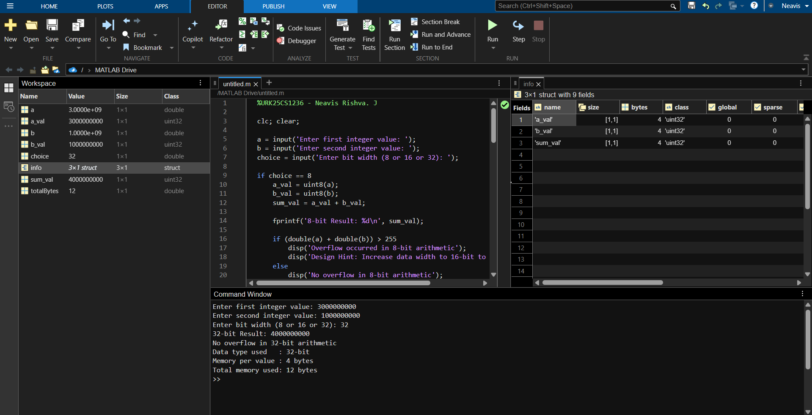

Sample Input & Sample Output
Input:
Enter first integer value: 3000000000
Enter second integer value: 1000000000
Enter bit width (8 or 16 OR 32): 32
Output:
32-bit Result: 4000000000
No overflow in 32-bit arithmetic
Data type used: 32-bit
Memory per value: 4 bytes
Total memory used: 12 bytes

  - Change the given program to perform subtraction of two unsigned integers using user-selected bit width (8 or 16) and detect underflow.
CODE
clc; clear;

a = input('Enter first unsigned integer: ');
b = input('Enter second unsigned integer: ');
choice = input('Enter bit width (8 or 16): ');

if choice == 8
a_val = uint8(a);
b_val = uint8(b);

result = a_val - b_val;

fprintf('8-bit Result: %d\n', result);

if a < b
disp('Underflow occurred in 8-bit arithmetic');
disp('Design Hint: Use 16-bit or signed integers to avoid underflow');
else
disp('No underflow in 8-bit arithmetic');
end

info = whos('a_val','b_val','result');
totalBytes = sum([info.bytes]);

fprintf('Data type used : 8-bit\n');
fprintf('Memory per value : 1 byte\n');
fprintf('Total memory used: %d bytes\n', totalBytes);

elseif choice == 16
a_val = uint16(a);
b_val = uint16(b);

result = a_val - b_val;

fprintf('16-bit Result: %d\n', result);

if a < b
disp('Underflow occurred in 16-bit arithmetic');
else
disp('No underflow in 16-bit arithmetic');
end

info = whos('a_val','b_val','result');
totalBytes = sum([info.bytes]);

fprintf('Data type used : 16-bit\n');
fprintf('Memory per value : 2 bytes\n');
fprintf('Total memory used: %d bytes\n', totalBytes);

else
disp('Invalid bit-width selection');
end

Sample Input & Sample Output
Input:
Enter first integer value: 20
Enter second integer value: 23
Enter bit width (8 or 16): 8
Output:
8-bit Result: 0
Underflow occurred in 8-bit arithmetic
Data type used : 8-bit
Memory per value : 1 byte
Total memory used: 3 bytes

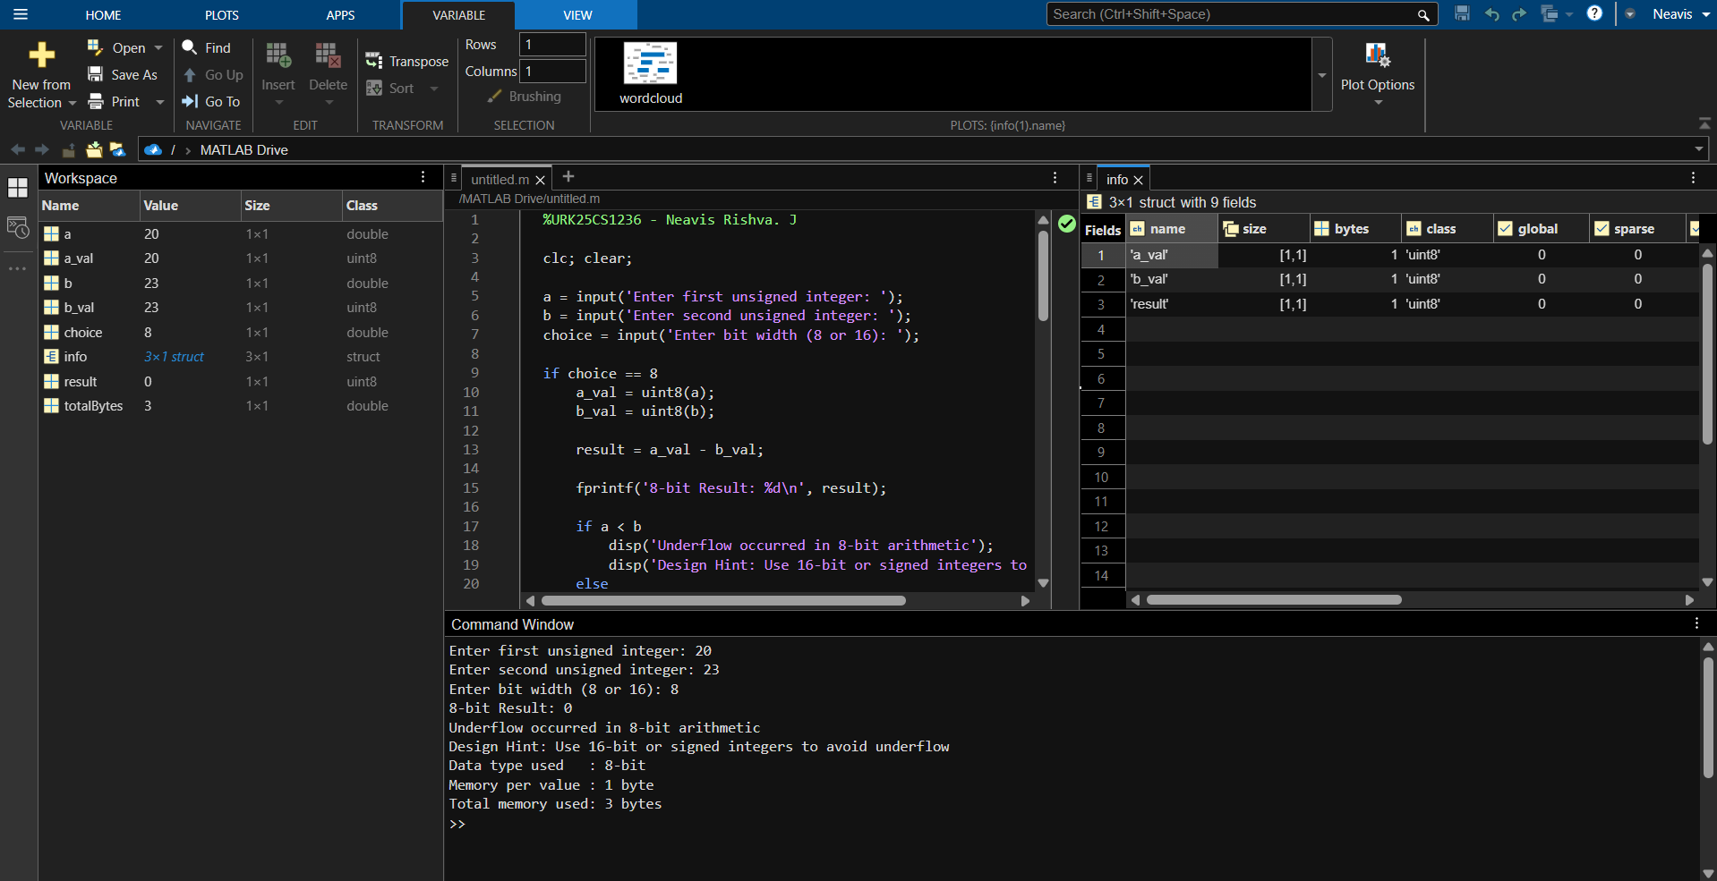
  - Modify the code to multiply two unsigned integers using 8-bit or 16-bit arithmetic and check for overflow.
CODE:
clc; clear;

a = input('Enter first unsigned integer: ');
b = input('Enter second unsigned integer: ');
choice = input('Enter bit width (8 or 16): ');

if choice == 8

a_val = uint8(a);
b_val = uint8(b);

result = a_val * b_val;

fprintf('8-bit Multiplication Result: %d\n', result);

if (double(a) * double(b)) > 255
disp('Overflow occurred in 8-bit arithmetic');
disp('Design Hint: Increase data width to 16-bit');
else
disp('No overflow in 8-bit arithmetic');
end

info = whos('a_val','b_val','result');
totalBytes = sum([info.bytes]);

fprintf('Data type used : 8-bit\n');
fprintf('Memory per value : 1 byte\n');
fprintf('Total memory used: %d bytes\n', totalBytes);

elseif choice == 16

a_val = uint16(a);
b_val = uint16(b);

result = a_val * b_val;

fprintf('16-bit Multiplication Result: %d\n', result);

if (double(a) * double(b)) > 65535
disp('Overflow occurred in 16-bit arithmetic');
else
disp('No overflow in 16-bit arithmetic');
end

info = whos('a_val','b_val','result');
totalBytes = sum([info.bytes]);

fprintf('Data type used : 16-bit\n');
fprintf('Memory per value : 2 bytes\n');
fprintf('Total memory used: %d bytes\n', totalBytes);

else
disp('Invalid bit-width selection');
end

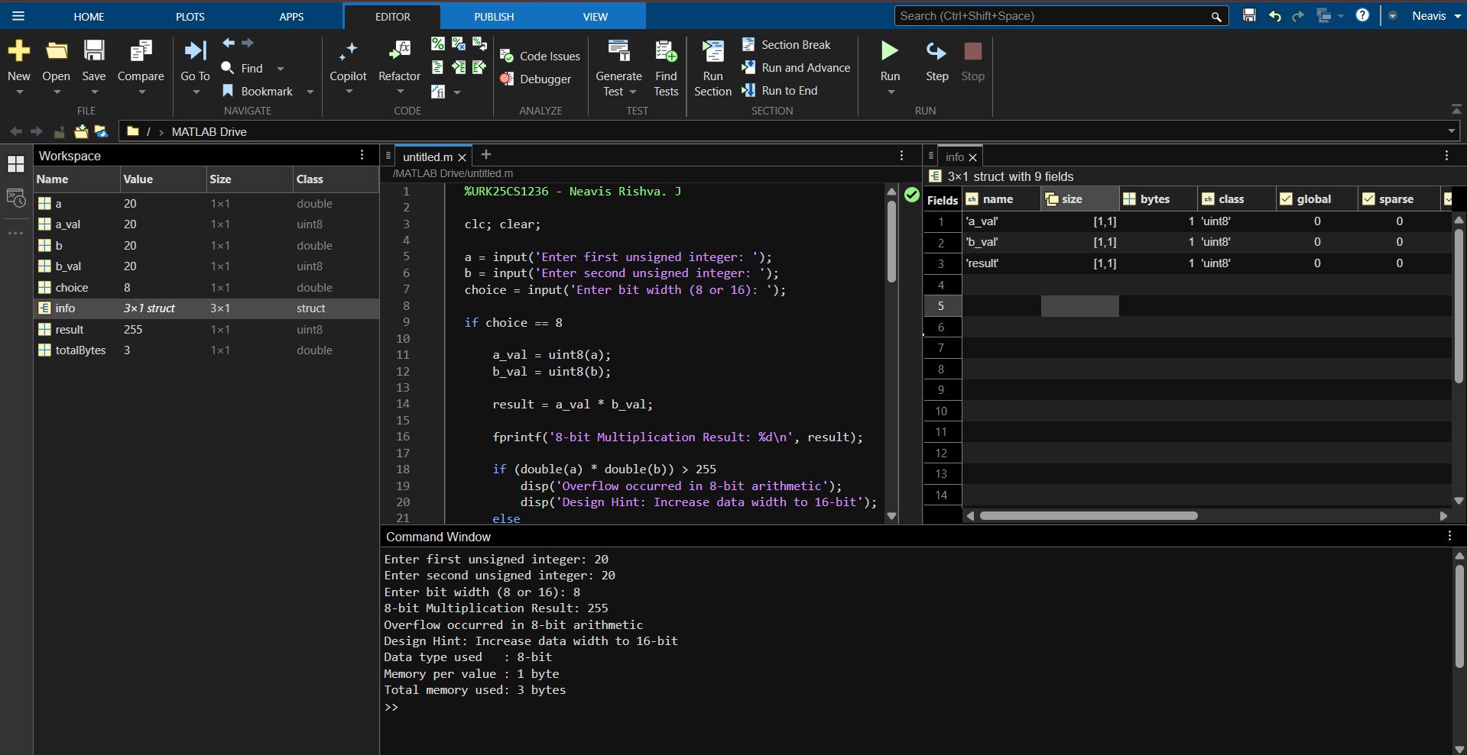

Sample Input & Sample Output
Input:
Enter first integer value: 20
Enter second integer value: 20
Enter bit width (8 or 16): 8
Output:
8-bit Result: 144
Overflow occurred in 8-bit arithmetic
Data type used: 8-bit
Memory per value: 1 byte
Total memory used: 3 bytes

  - Write a MATLAB program to subtract two unsigned integers and display the result using 8-bit or 16-bit arithmetic.
CODE:
clc; clear;

a = input('Enter first unsigned integer: ');
b = input('Enter second unsigned integer: ');
choice = input('Enter bit width (8 or 16): ');

if choice == 8

a_val = uint8(a);
b_val = uint8(b);
diff_val = a_val - b_val;

fprintf('8-bit Result: %d\n', diff_val);

if a < b
disp('Underflow occurred in 8-bit arithmetic');
disp('Design Hint: Use 16-bit or signed integers to avoid underflow');
else
disp('No underflow in 8-bit arithmetic');
end

info = whos('a_val','b_val','diff_val');
totalBytes = sum([info.bytes]);

fprintf('Data type used : 8-bit\n');
fprintf('Memory per value : 1 byte\n');
fprintf('Total memory used: %d bytes\n', totalBytes);

elseif choice == 16

a_val = uint16(a);
b_val = uint16(b);
diff_val = a_val - b_val;

fprintf('16-bit Result: %d\n', diff_val);

if a < b
disp('Underflow occurred in 16-bit arithmetic');
else
disp('No underflow in 16-bit arithmetic');
end

info = whos('a_val','b_val','diff_val');
totalBytes = sum([info.bytes]);

fprintf('Data type used : 16-bit\n');
fprintf('Memory per value : 2 bytes\n');
fprintf('Total memory used: %d bytes\n', totalBytes);

else
disp('Invalid bit-width selection');
end
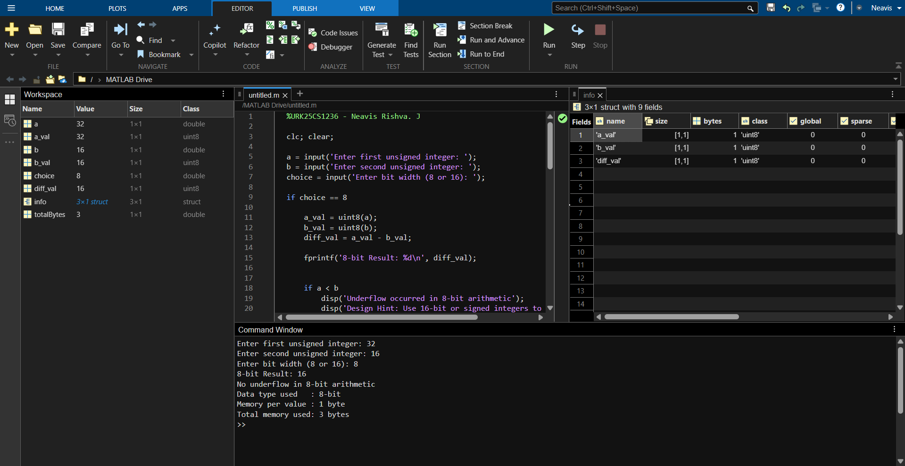
Sample Input & Sample Output
Input:
Enter first integer value: 32
Enter second integer value: 116
Enter bit width (8 or 16): 8
Output:
8-bit Result: 16
Overflow occurred in 8-bit arithmetic
Data type used: 8-bit
Memory per value: 1 byte
Total memory used: 3 bytes

  - Write a MATLAB program to divide two unsigned integers using 8-bit or 16-bit arithmetic and handle division-by-zero conditions.
CODE:
clc; clear;

a = input('Enter first unsigned integer: ');
b = input('Enter second unsigned integer: ');
choice = input('Enter bit width (8 or 16): ');

% Check division by zero
if b == 0
disp('Error: Division by zero is not allowed');
else

if choice == 8

a_val = uint8(a);
b_val = uint8(b);
div_val = a_val / b_val;

fprintf('8-bit Division Result: %d\n', div_val);

info = whos('a_val','b_val','div_val');
totalBytes = sum([info.bytes]);

fprintf('Data type used : 8-bit\n');
fprintf('Memory per value : 1 byte\n');
fprintf('Total memory used: %d bytes\n', totalBytes);

elseif choice == 16

a_val = uint16(a);
b_val = uint16(b);
div_val = a_val / b_val;

fprintf('16-bit Division Result: %d\n', div_val);

info = whos('a_val','b_val','div_val');
totalBytes = sum([info.bytes]);

fprintf('Data type used : 16-bit\n');
fprintf('Memory per value : 2 bytes\n');
fprintf('Total memory used: %d bytes\n', totalBytes);

else
disp('Invalid bit-width selection');
end

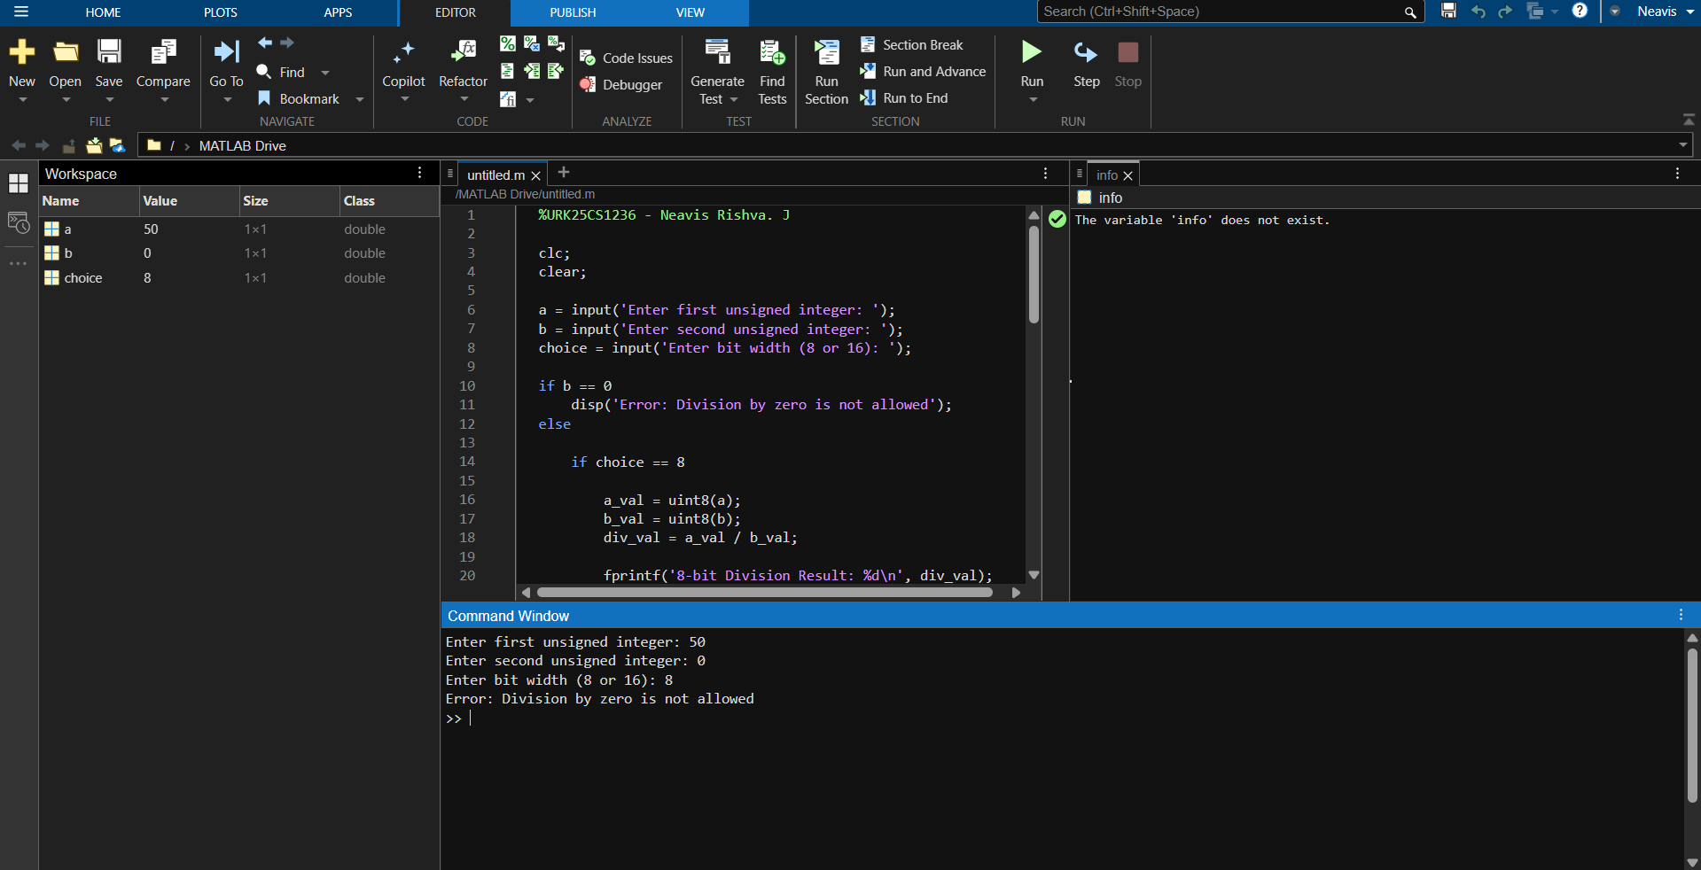
Sample Input & Sample Output
Input:
Enter first integer value: 50
Enter second integer value: 0
Enter bit width (8 or 16): 8
Output:
Error: Division by zero is not allowed

- Suggested Assessment Scheme

The performance indicators given serve as a guideline for assessing the ‘process-related skills/LOs’ (marks to be awarded in real-time in the laboratory by the faculty member, as these cannot be measured after the practicum is over) and ‘product-related skills/LOs’

Note: The weightage for the process-related skills and product-related skills will change depending on the PrO, COs, and the competency related to the concerned course.

Performance Indicators |  | Maximum Marks | Marks Obtained
Process-related Skills: 18 Marks - 60%
1 | Correctly creating and running MATLAB scripts (coding hygiene, commenting, workspace handling). | 6
2 | Selecting appropriate arithmetic operations for the given data. | 5
3 | Following safety, coding ethics, and good laboratory practices (file management, backups). | 4
4 | Contribution as a team member (peer collaboration, sharing datasets, debugging). | 3
Product-related Skills: 12 Marks - 40%
1 | Producing accurate computation results and well-formatted MATLAB Table output. | 3
2 | Correct interpretation of logical comparisons and arithmetic patterns. | 2
3 | Interpretation of results (clarity, mathematical validity). | 3
4 | Drawing meaningful conclusions using NEP-aligned verbs (justify, determine, generate). | 2
5 | Ability to answer practicum-related higher-order questions. | 1
6 | Submitting the report on time with screenshots and code | 1
Total |  | 30

To be filled by Student:

S.No. | Name of the Student | Register No.
1 | Neavis Rishva. J | URK25CS1236

To be filled by the Faculty Member:
Marks Obtained |  |  | Name and Designation of the Faculty Member | Date of Evaluation
Process-Related Skills  (18) | Product-Related Skills (12) | Total  (30)

*******

